TRACKING BOYS’ PROGRESS
IN THE MODIFIED CUB SCOUT ADVENTURE PLAN
Judy and I have found several places on the web where there are aids to use to track boys’ progress in the modified Adventure Plan. Judy is placing a more detail in Baloo’s Bugle, Part IV – Den Meeting Helps.
- The Bobwhite Bather blog site (https://bobwhiteblather.com/mid-year-cub-scout-program-updates/ ) has a discussion of changes.
- Cubmaster Tom, responded providing links to documents he formatted to paste into the boys’ books for each modified Adventure. See example below:
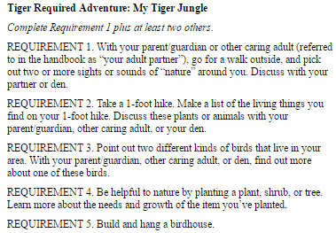
The complete Tiger document is at: https://docs.google.com/document/d/1ka_AkwxDkKgNjLrAOUHzbQQqCkruDCC8RyxtMFvrFO8/edit?usp=sharing. The links for the other ranks are in the comment on Bobwhite Blather.
- Bert Bender, Atlanta Area Council, replied,
Having finished several deep dives through the requirements changes, I’ve updated the page at http://www.southfultonscouting.com/node/3557 to not only show exactly what got changed and what didn’t change, but now also add comments intended to be a practical guide to whether you need to look at the new 11/30/16 language, and whether when those might be a useful alternative.
Comments after some Adventures encourage (sometimes plead) that dens avoid the “easy button” approach. Doing the June 1, 2015 handbook elements will often result in better outcomes and experience in Cub Scouting.
- Utah National Parks Council’s Akelas Council Blogspot has revised paper tracking sheets (http://akelascouncil.blogspot.com/) Thanks to Celeste Hunt for creating these.
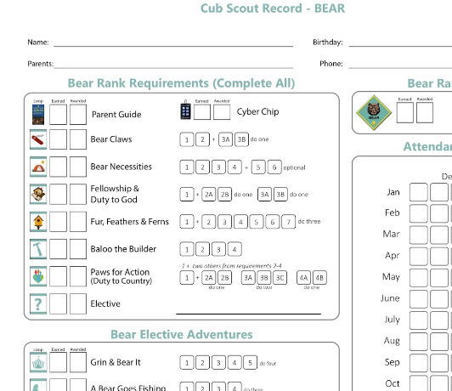
Celeste says, “Tracking, planning, and recognition are so important in Cub Scouts. This new tracking sheet helps you to be able to keep track of where each boy is at towards the Bear, Adventures, and Cyber Chip requirements. I print 2 copies of the tracker on cardstock for each boy. One for his book and one for my leader binder. I place it next to the trackers for the religious and other awards we are doing. I have tab for every boy with all his trackers. Complete information on each boy in one place. Not every boy is there every week. By doing this, I always know what each boy has done. If the parents ever have questions, I have a place to check, and I can always copy each tracking sheet to show them where their boy is.

